ASA24® Participant Help Guide for ASA24-2014, ASA24-Kids-2014, and ASA24-Canada-2014
Table of Contents

General Questions
How do I complete an ASA24 food recall? 3
What should I do if I cannot complete an ASA24 food recall after starting it? 15
Reporting Foods and Drinks
How do I add a food or drink? 4
What do I do if I can’t find a food or drink? 6
Can I enter a recipe? 6
How do I enter restaurant foods or drinks? 7
What do I do if I can’t find an item that I added to my food or drink? 13
Can I save foods and drinks as “favorites” so that I don’t have to search for them later? 14
Moving to the Next Step
What do I do after I’m done adding foods and drinks to a meal or snack? 7
How do I add a meal or snack? 8
What do I do after I’ve finished reporting everything I ate and drank? 9
I am stuck and can’t move on – what should I do? 15
Editing and Making Changes
How do I change the time, place or other information about a meal or snack? 9
How do I copy a food or drink from one meal to another? 10
How do I move a food or drink from one meal to another? 10
How do I change the foods and drinks I’ve added to My Foods and Drinks? 11
What do I do if I selected Done entering all meals and snacks but then want to add another food or drink or make a change? 12
What do I do if I want to make a change during the Final Review? 12
Reporting Amounts
What if the portion sizes shown don’t match what I had? 13

Additions
How do I enter something that I added to my food or drink? 13
What do I do if I can’t find an item that I added to my food or drink? 13
Why can’t I add salt and pepper to my foods? 14
Vitamins, Minerals, and Supplements
What if I didn’t take any vitamins, minerals, or other supplements yesterday? 15
Troubleshooting
I am stuck and can’t move on – what should I do? 15
I can’t hear the penguin – what should I do? 16
How do I turn the penguin off or back on again? 16
How do I change the text size to be larger or smaller? 16
Where can I find help? 17

How do I complete an ASA24 food recall?
To complete an ASA24 food recall in the system, you will be asked to report everything that you had to eat and drink from midnight to midnight yesterday, midnight to midnight the day before yesterday, or the past 24 hours, depending upon the study you are participating in.
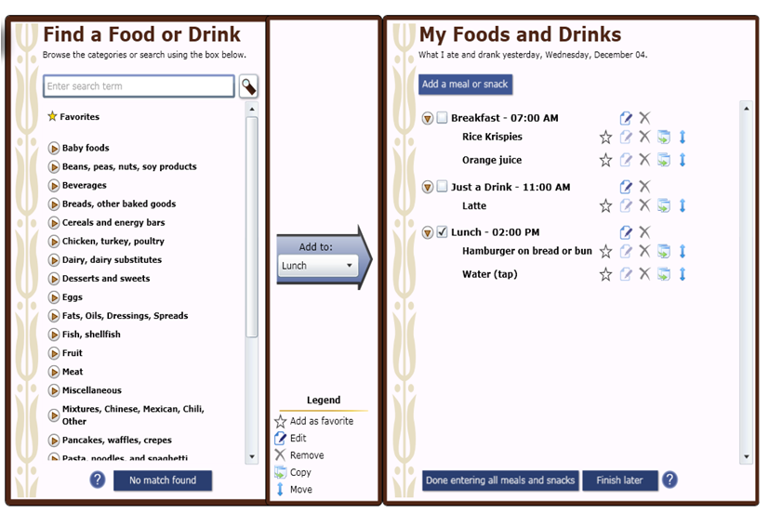
The left Find a Food or Drink panel is where you look for the foods and drinks you had. You can search for a food or drink by typing in the Search box, or you can browse the categories by selecting the triangles to see what is below. Foods and drinks are organized into categories of similar items. For example, lots of cereals are under Cold Cereals.
The My Foods and Drinks panel is where the foods and drinks you report will be listed. You can find the date you are to report on at the top of the My Foods and Drinks panel, on the right side of the menu.
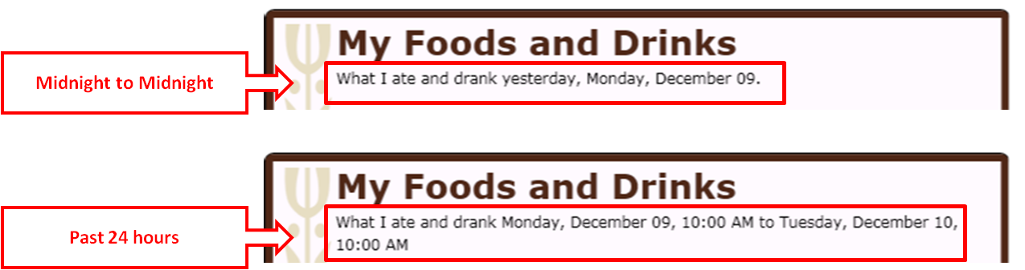
- You will first be asked to report the foods and drinks that you had at each meal or snack. These will be listed in the My Foods and Drinks panel.
- Then you will be asked for details about each food and drink, such as how much you ate or drank and whether you added anything (for example, pouring milk on cereal).
- You will have a chance to review everything you reported and make changes if you have made a mistake or forgot something.
- You will then be asked about foods and drinks that people often forget to report.
- If the person who asked you to complete the ASA24 food recall has included the Supplements section, you will also be asked about any vitamins, minerals or dietary supplements that you had during the same time period.
Back to top
How do I add a food or drink?
After you have added a meal by selecting Add a meal or snack at the top of the My Foods and Drinks panel on the right, look for the foods and drinks you had in the left Find a Food or Drink panel. From here you have two options:
Option 1: Search for something by using the search box at the top of the left panel.
As you type a food or drink into the box, suggestions will be presented.
You can select one of the suggestions as a search term or finish typing your search term and select either enter or the magnifying glass icon to the right of the search box to do a search. Two types of matches to your search will appear, Common matches and Other matches. Select the food or drink that best matches what you want to report.
Option 2: Browse by looking through the food and drink categories.
Select the triangle to view the specific items that are included in the list for a specific category. You can select the triangle by clicking on it or by using the arrow keys.
Try both browsing and searching to find your food or drink. When you find what you are looking for, highlight it and click on the arrow in the middle to move it to My Foods and Drinks on the right.
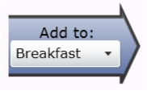
That food or drink will then appear under the meal or snack you are working on as indicated by the meal listed in the box on the arrow. The meal you are working on is also indicated by a checkbox on the My Foods and Drinks panel.
You can then browse or search for the next food or drink that you had at that meal. After you have reported everything you had at that meal or snack, press Add a meal or snack, which is at the top of the My Foods and Drinks panel on the right. Or if you are done with all of your meals and snacks, press Done entering all meal and snacks on the bottom of the My Foods and Drinks panel.
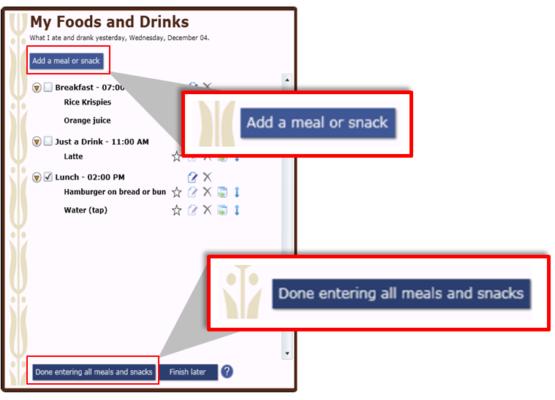
If you are having trouble finding a food or drink, please see What do I do if I can’t find a food or drink?
Back to top
What do I do if I can’t find a food or drink?
Try browsing through the food and drink categories to find something close. If that doesn’t work, try typing it – or something close – into the Search box. If you still can’t find the item, or a close match, press the No Match Found button at the bottom of the left panel.
Then you can type in the name or a description of the item into the text box that appears.
Back to top
Can I enter a recipe?
The ASA24 system does not allow you to add recipes. Please browse or search for a food or drink similar to what you ate or drank. If you cannot find the food or drink, please see What do I do if I can’t find a food or drink?
Back to top
How do I enter restaurant foods or drinks?
Some foods from restaurants are identified by the restaurant name, but others are not. You can try searching using the name of the restaurant to check if the food you are looking for is there. If not, try searching or browsing for a more general description, like hamburger, soda, taco, or milkshake. The example below shows the first part of the results of a search for ‘hamburger’. Note that both generic items (e.g., Hamburger on bread or bun) and branded items (e.g., Burger King Hamburger) are included in the food list.
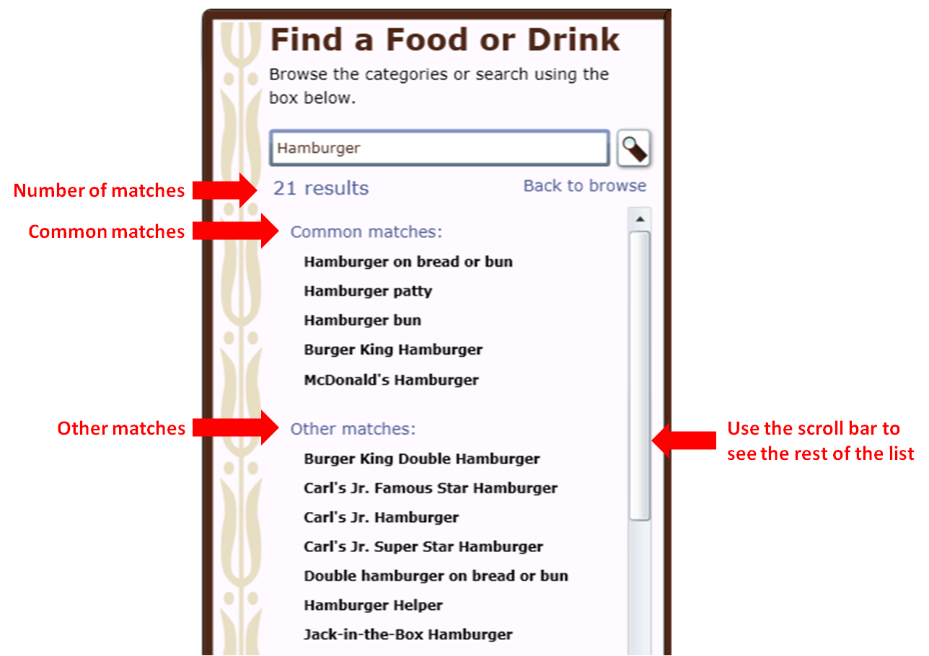
Back to top
What do I do after I’m done adding foods and drinks to a meal or snack?
When you have finished reporting all the foods and drinks you had at a meal or snack, select Add a meal or snack found at the top of the My Foods and Drinks panel on the right if you need to add another meal or snack.
You will then be prompted to add the details of the next meal or snack you want to report. Or if you are done with all of your meals and snacks, select Done entering all meals and snacks at the bottom of the My Foods and Drinks panel on the right.
Back to top
How do I add a meal or snack?
Select Add a meal or snack at the top of the My Foods and Drinks panel on the right.
You will then be asked information about the meal or snack (for example, what meal it was and what time you had it). Once you enter that information, press the Next button in the lower right-hand corner of the window.
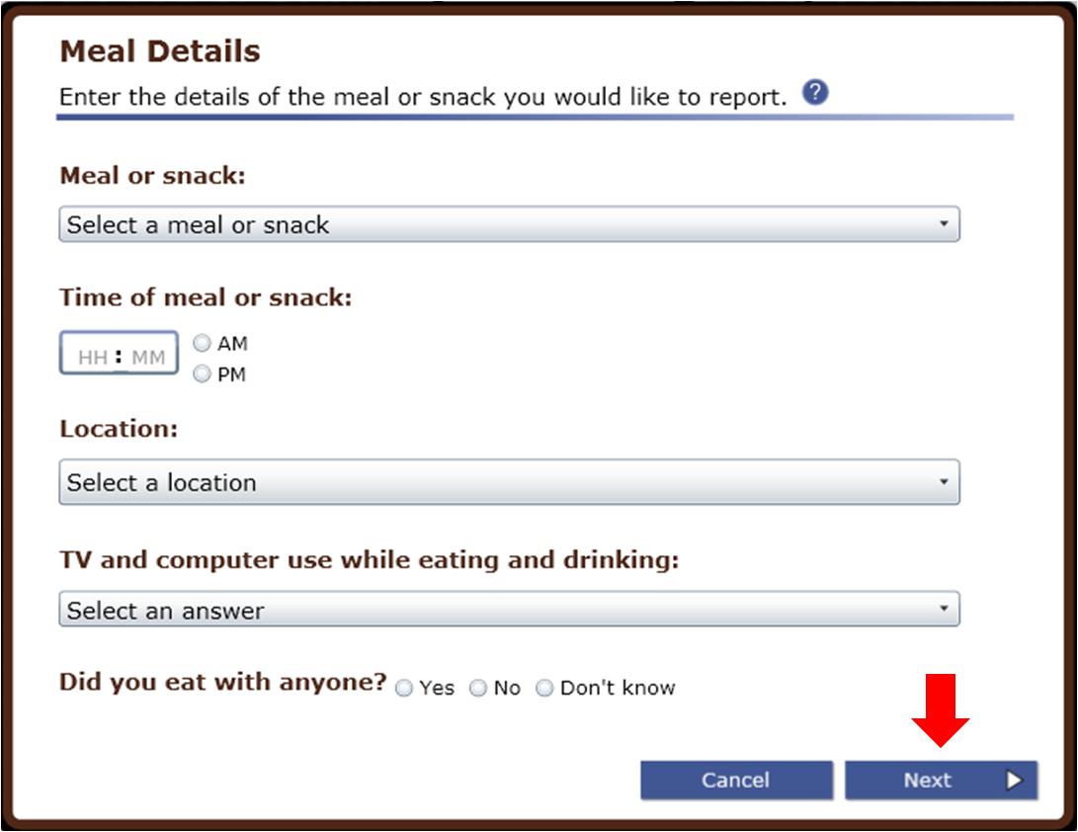
You will then return to the main screen to browse or search for the foods and drinks you had at that meal or snack using the Find a Food or Drink panel found on the left.
Back to top
What do I do after I’ve finished reporting everything I ate and drank?
Once you’ve reported everything you had to eat and drink at all of your meals and snacks for your reporting period, press Done entering all meals and snacks at the bottom of the My Foods and Drinks panel on the right.
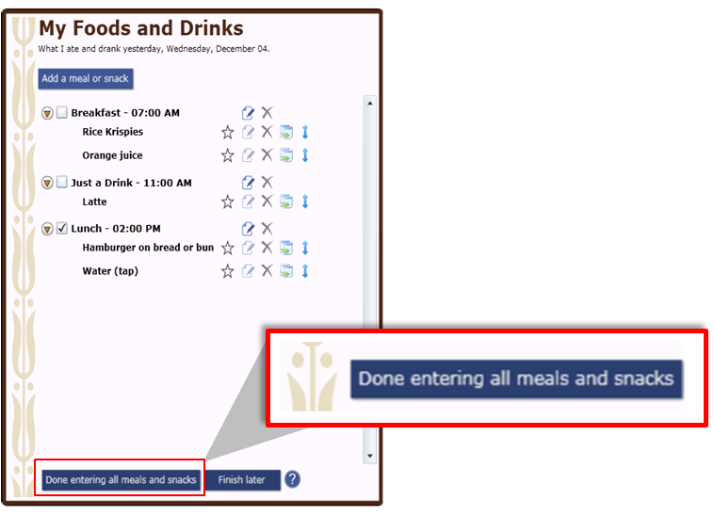
You will then move on to report the details of each food and drink, such as how much you had and whether you added anything (for example, milk to cereal).
Back to top
How do I change the time, place or other information about a meal or snack?
Click the edit icon to the right of each meal or snack on the My Foods and Drinks panel, and a meal screen will appear. It is there that you can make changes.
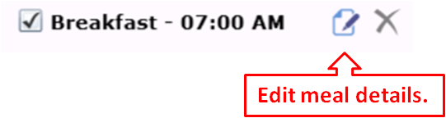
Back to top
How do I copy a food or drink from one meal to another?
If you had the exact same food or drink at more than one meal or snack, after you’ve entered it once, you can copy it to another meal. Use the copy icon to the right of the food or drink you want to copy. You will then be asked what meal or snack you want to copy it into. You should select the meal from the drop-down list. The list will include all meals you have entered for the current reporting period. Click on the Copy button when you have selected the correct meal.
Step 1:
Step 2:
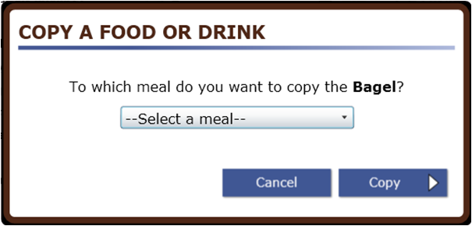
Back to top
How do I move a food or drink from one meal to another?
Select the move icon to the right of the food you want to move on the My Foods and Drinks panel.
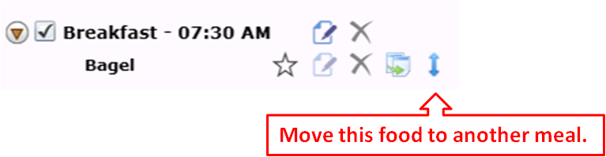
You will then be asked what meal or snack you want to move it to. You should select the meal from the drop-down list. The list will include all meals you have entered for the current reporting period. Click on the Move button when you have selected the correct meal.
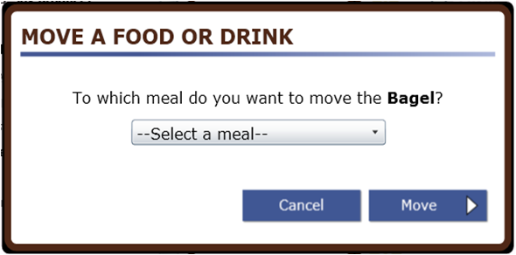
Back to top
How do I change the foods and drinks I’ve added to My Foods and Drinks?
You can use the icons to the right of the food or drink you have reported to delete, move, copy, or edit a food or drink.
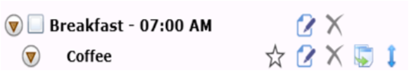

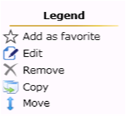 | - The Add as favorite icon allows you to save a food or drink as a favorite. Once selected it will appear as a favorite food and you can select in the Find a Food or Drink panel during a current or future ASA24 session.  - The Edit icon allows you to edit details about your food after they have been reported.  - The Remove icon allows you to delete a food or drink.  - The Copy icon allows you to copy a food or drink to another meal. Please see How do I copy a food or drink from one meal to another?  - The Move icon allows you to move a food or drink to another meal. Please see How do I move a food or drink from one meal to another?
Back to top
What do I do if I selected Done with all meals and snacks but then want to add another food or drink or make a change?
If you are in the middle of reporting details like portion size or something you added to a food or drink, you must first finish reporting details for that food or drink before you can add another food or drink or make a change. You can also make these types of changes later, during the final review. For more information see How do I change the foods and drinks I’ve added to My Foods and Drinks?
If you want to change details of the meal or snack, like what meal it was or what time you had it, please see How do I change the time, place or other information about a meal or snack?
Back to top
What do I do if I want to make a change during the Final Review?
Select Make Changes at the bottom of the Review screen to browse or search for foods or drinks; then use the Add a meal or snack button on the My Foods and Drinks panel or icons next to each meal, food or drink to make changes.
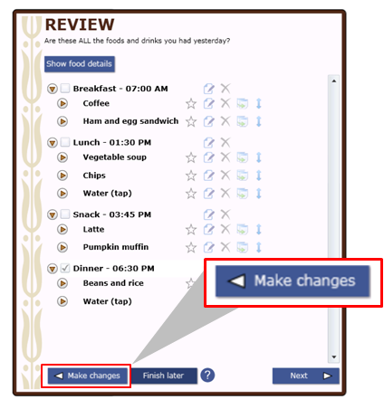
If you want to change the time, place or other details of a meal or snack, Please see How do I change the time, place or other information about a meal or snack?
If you want to change a food or drink you reported please see How do I change the foods and drinks I’ve added to My Foods and Drinks?
Back to top
What if the portion sizes shown don’t match what I had?
Choose the portion size that is the closest to what you ate or drank. You can select less than if you had less than the smallest portion shown, or specify an amount that is more than the largest portion. Remember that the portion size pictures show how much you ate, not what you started with or were served.
Back to top
How do I enter something that I added to my food or drink?
When answering details about your foods and drinks, you may be asked whether you added anything like cream cheese to your bagel or lemon to your tea. Cream cheese and lemon are examples of what are called additions. You may have already reported your addition(s) as a separate item so there is no need to report them again at this point. If you have not already reported the addition(s) to the food, you can search or browse for additions and use the right arrow on the screen to report your additions. Selected additions will appear on the right. If you make a mistake, you can use the left arrow to remove an addition.
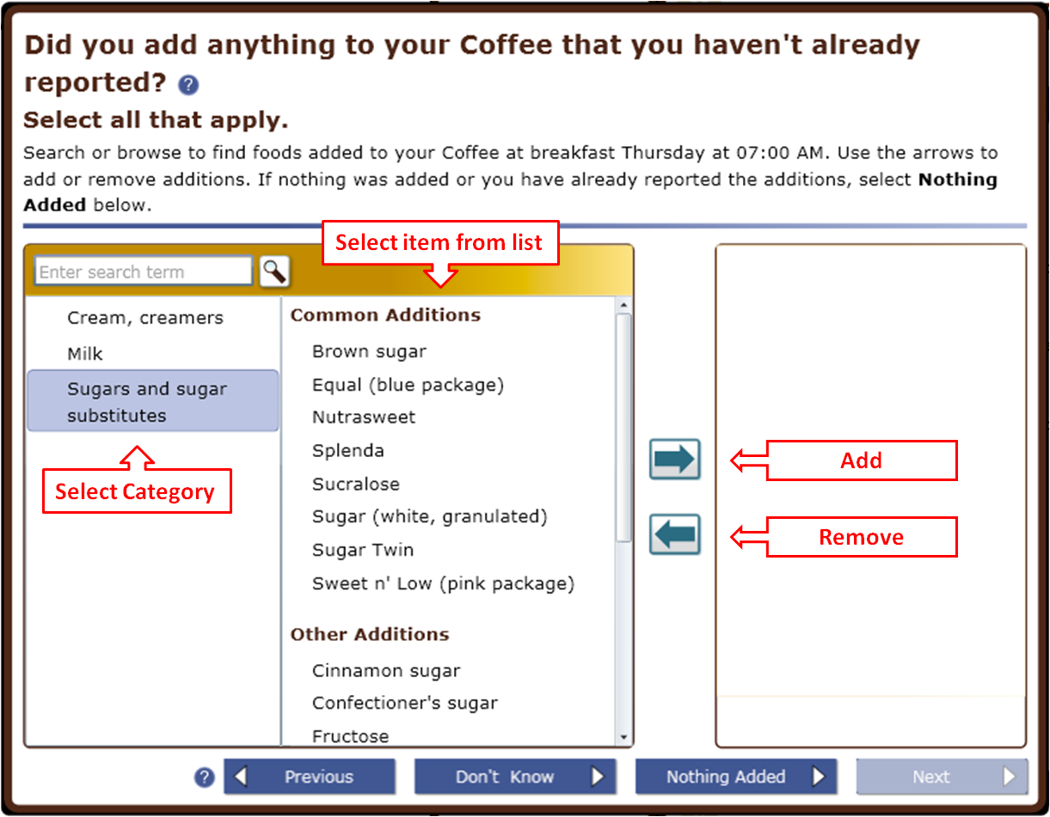
Back to top
What do I do if I can’t find an item that I added to my food or drink?
If you can’t find an item that you added, try to find a close match.
Back to top
Can I save foods and drinks as “favorites” so that I don’t have to search for them later?
If you want to save a food as a favorite you can do so by selecting the star icon which appears next to a food or drink in both Find a Food or Drink panel and the My Foods and Drinks panel.
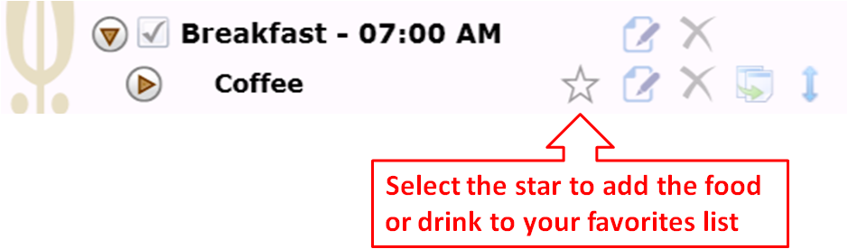
When you select a favorite, it appears in a list of Favorites at the top of the Find a Food or Drink panel so that you can easily select and report it for the current or future sessions of ASA24.
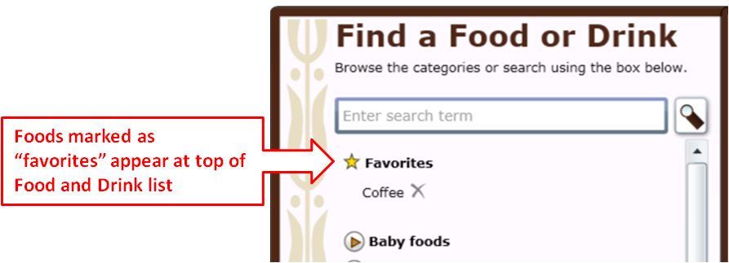
Back to top
Why can’t I add salt and pepper to my foods?
Salt and pepper aren’t included in the ASA24 food and drink library so you don’t need to worry about adding them.
Back to top
What if I didn’t take any vitamins, minerals, or other supplements yesterday?
If you didn’t take any vitamins, minerals, or other supplements yesterday, select No Supplements to report at the bottom of the My Supplements panel on the right.
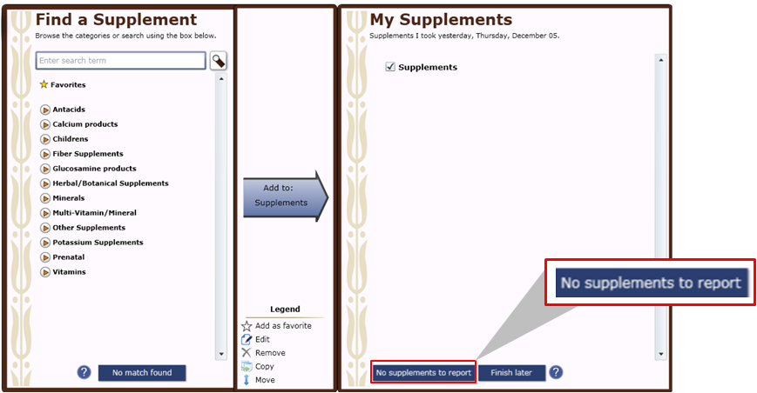
Back to top
What should I do if I cannot complete an ASA24 food recall after starting it?
It’s best to report all your foods and drinks at one time, and for some studies this is required and the study staff will have instructed you to complete the ASA24 food recall in one sitting. For studies for which a single sitting is not required, if you cannot complete the ASA24 food recall after starting it, press Finish later on the bottom of the My Foods and Drinks or My Supplements panel on the right side of the screen.
Your answers will be saved and you can come back later today to finish. If you had a problem like your browser or computer shutting down, try to log back in today – your answers are saved as you complete each step so you will be able to see where you left off and finish.
Back to top
I am stuck and can’t move on – what should I do?
Make sure that you have answered all of the questions on the screen. Most screens have a Next button that won’t be active until you answer everything.
If your internet browser or computer is not responding and you need to shut down, you can log back in the same day to finish – your answers are saved as you complete each step so you will be able to see where you left off or close to it.
Back to top
I can’t hear the penguin – what should I do?
If you can’t hear the penguin, check to make sure that your computer speakers are turned on and try adjusting the volume. Also, select Penguin Toolbar in the top left corner of the screen to make sure that the penguin’s voice is turned on.
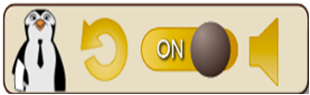
If you don’t have speakers or if your speakers aren’t working, you can read what the penguin says in the text bubbles.
Back to top
How do I turn the penguin off or back on again?
Select Penguin Toolbar at the top left of the screen.
You can then turn off the penguin’s voice (you can still read what the penguin says in the text bubbles). You can also make the penguin disappear if you are comfortable with the ASA24 system and don’t need help. If you change your mind, go to the Penguin Toolbar again to turn the penguin back on.
Back to top
How do I change the text size to be larger or smaller?
Select one of the three As (A A A) in the top right corner of the screen to change the font size to small, medium, or large.
Back to top
Where can I find help?
Help is available in three places:
- Review the questions and answers in this document. (This document may be accessed from the website clicking help link in the header.)
- Make sure the penguin is turned on (see Penguin Toolbar in the top left of the screen). Selecting the repeat icon will allow you to obtain instructions specific to what is happening on the screen you are currently working on. The penguin will repeat instructions when you select the arrow in the image for a topic you need help with.
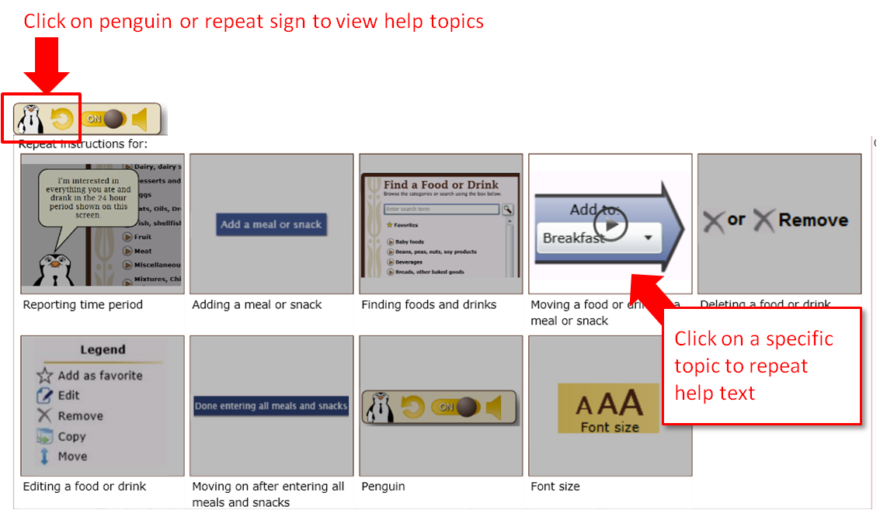
- Select the blue question marks () that appear on some screens for additional help.
If you require further assistance, please contact the person who asked you to complete the ASA24 food recall.
Back to top

