Welcome to ASA24. This page provides tips for completing your 24-hour dietary recall.
General Questions
How do I complete ASA24?
How do I change the text size to be larger or smaller?
What should I do if I cannot complete ASA24 after starting it?
Reporting Foods and Drinks
How do I add a food or drink?
What do I do if I can’t find a food or drink?
Can I enter a recipe?
How do I enter restaurant foods or drinks?
What do I do if I can’t find an item that I added to my food or drink?
Moving to Next Step
What do I do after I’m done adding foods and drinks to a meal or snack?
How do I add a new meal or snack?
What do I do after I’ve finished reporting everything I ate and drank?
I am stuck and can’t move on – what should I do?
Editing and Making Changes
How do I change the time, place or other details of a meal or snack?
How do I copy a food or drink from one meal to another?
How do I move a food or drink from one meal to another?
How do I change the foods and drinks I’ve added to My Foods and Drinks?
What do I do if I selected Done entering all meals and snacks but then want to add another food or drink or make a change?
What do I do if I want to make a change during the Final Review?
Reporting Amounts
What if the portion sizes shown don’t match what I had?
Additions
How do I enter something that I added to my food or drink?
What do I do if I can’t find an item that I added to my food or drink?
Why can’t I add salt and pepper to my foods?
Vitamins, Minerals, and Supplements
What if I didn’t take any vitamins, minerals, or other supplements yesterday?
Troubleshooting
I am stuck and can’t move on – what should I do?
I can’t hear the penguin – what should I do?
How do I turn the penguin off or back on again?
How do I change the text size to be larger or smaller?
Where can I find help?

How do I complete ASA24?
To complete ASA24, you will be asked to report everything that you had to eat and drink from midnight to midnight yesterday or midnight to midnight the day before yesterday, depending upon the study you are participating in.
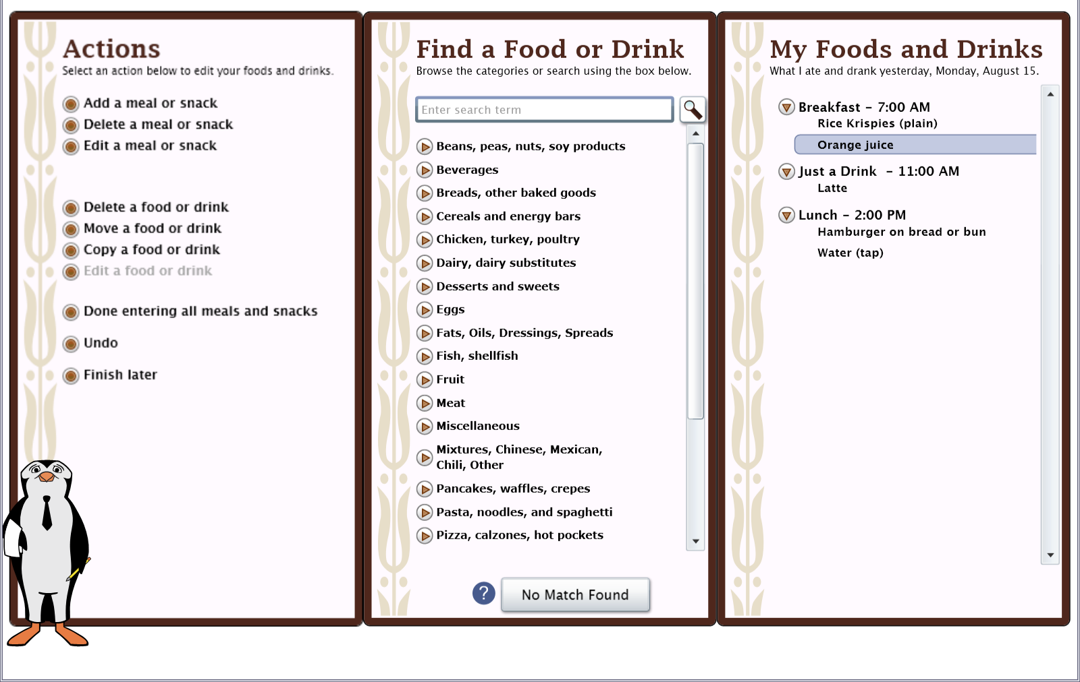
The Actions panel on the left lists actions you can use to make changes. For example, this is the where you will go when you want to add a new meal or snack, or make changes to information you entered previously. You will also come back to this panel when you are done entering information.
The middle Find a Food or Drink panel is where you look for the foods and drinks you had. You can search for a food or drink by typing in the Search box, or you can browse the categories by selecting the triangles to see what is below. Foods and drinks are organized into categories of similar items. For example, lots of cereals are under Cold Cereals.
The My Food and Drinks panel is where the foods and drinks you report will be listed. You can find the date you are to report on at the top of the My Foods and Drinks panel, the right most panel on the menu.
- You will first be asked to report the foods and drinks that you had at each meal or snack. These will be listed in the My Foods and Drinks panel.
- Then you will be asked for details about each food and drink, such as how much you ate or drank and whether you added anything (for example, pouring milk on cereal).
- You will have a chance to review everything you reported and make changes if you have made a mistake or forgot something.
- You will then be asked about foods and drinks that people often forget to report.
- If the person who asked you to complete ASA24 has included the Supplements section, you will also be asked about any vitamins, minerals or dietary supplements that you had during the same time period.
Back to top
How do I add a food or drink?
After you have added a meal by selecting Add a Meal or Snack from the left Actions panel, look for the foods and drinks you had in the middle Find a Food or Drink panel. You can:
- Search for something by using the search box at the top of the middle panel, or
- Browse by looking through the food and drink categories. Select the triangle to view the specific items that are included in the list for a specific category. You can select the triangle by clicking on it with your mouse or by using the arrow keys.
Try both browsing and searching to find your food or drink. When you find what you are looking for, double click on it or highlight it and press Enter to move it to My Foods and Drinks on the right. That food or drink will then appear under the meal or snack you are working on.
You can then browse or search for the next food or drink that you had at that meal. After you have reported everything you had at that meal or snack, press Add a new meal or snack, which is on the Actions panel on the left. Or if you are done with all of your meals and snacks, press Done entering all meal and snacks on the Actions panel.
If you are having trouble finding a food or drink, please see What do I do if I can’t find a food or drink?
Back to top
What do I do if I can’t find a food or drink?
Try browsing through the food and drink categories to find something close. If that doesn’t work, try typing it – or something close – into the Search box. If you still can’t find the item, or a close match, press the No Match Found button at the bottom of the middle panel.
Then you can type in the name or a description of the item into the text box that appears.
Back to top
Can I enter a recipe?
ASA24 does not allow you to add recipes. Please browse or search for a food or drink similar to what you ate or drank. If you cannot find the food or drink, please see What do I do if I can’t find a food or drink?
Back to top
How do I enter restaurant foods or drinks?
Some foods from restaurants are identified by the restaurant name, but others are not. You can try searching using the name of the restaurant to check if the food you are looking for is there. If not, try searching or browsing for a more general description, like hamburger, soda, taco, or milkshake. The example below shows the first part of the results of a search for ‘hamburger’.
Back to top
What do I do after I’m done adding foods and drinks to a meal or snack?
When you have finished reporting all the foods and drinks you had at a meal or snack, select Add a Meal or Snack found on the Actions panel on the left if you need to add another meal or snack.
You will then be prompted to add the details of the next meal or snack you want to report. Or if you are done with all of your meals and snacks, select Done entering all meals and snacks on the Actions panel.
Back to top
How do I add a meal or snack?
Select Add a Meal or Snack using the Actions panel on the left.
You will then be asked information about the meal or snack (for example, what meal it was and what time you had it). Once you enter that information, press the Next button in the lower right-hand corner of the window.
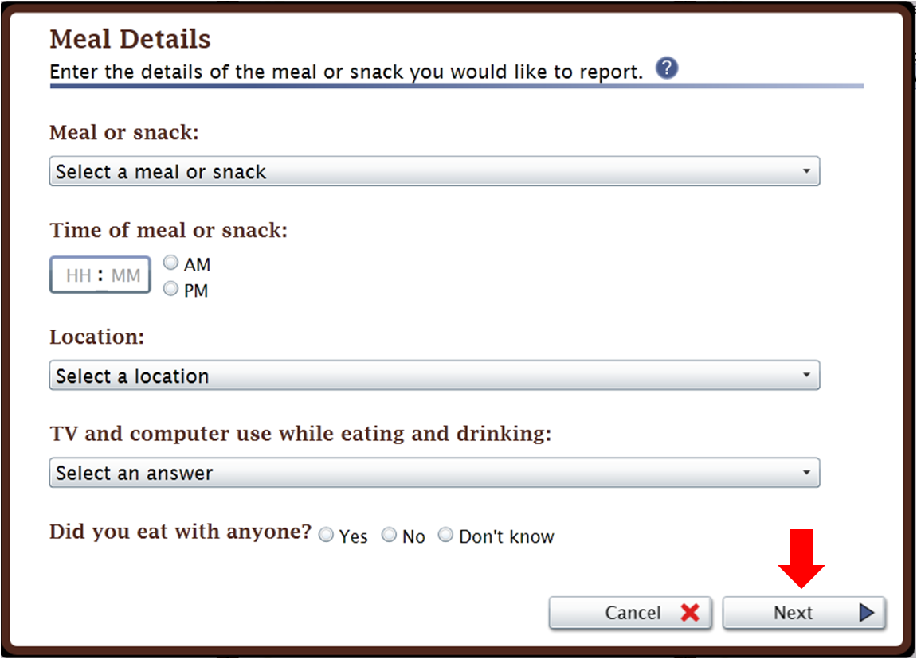
You will then return to the main screen to browse or search for the foods and drinks you had at that meal or snack using the Find a Food or Drink panel found in the middle.
Back to top
What do I do after I’ve finished reporting everything I ate and drank?
Once you’ve reported everything you had to eat and drink at all of your meals and snacks yesterday from midnight to midnight, press Done entering all meals and snacks on the Actions panel on the left.
You will then move on to report the details of each food and drink, such as how much you had and whether you added anything (for example, milk to cereal).
Back to top
How do I change the time, place or other information about a meal or snack?
Select the meal or snack you want to change on the My Foods and Drinks panel on the right; then select Edit a meal or snack under Actions, on the left of the screen.
Back to top
How do I copy a food or drink from one meal to another?
If you had the exact same food or drink at more than one meal or snack, after you’ve entered it once, you can copy it to another meal. Select the food or drink you want to copy so that it is highlighted and then select Copy a food or drink on the Actions panel. You will then be asked what meal or snack you want to copy it into.

Back to top
How do I move a food or drink from one meal to another?
Select the food or drink you want to move so that it is highlighted and then select Move a food or drink on the Actions panel at the left of the screen.
You will then be asked what meal or snack you want to move it to. You should select the meal from the drop-down list. The list will include all meals you have entered for the current date. Click on the Move button when you have selected the correct meal.
Back to top
How do I change the foods and drinks I’ve added to My Foods and Drinks?
You can use the Actions at the left of the screen to delete, move, copy, or edit a food or drink.
- First, highlight the food or drink.
- Then press the action you want on the Actions panel.
Back to top
What do I do if I selected Done with all meals and snacks but then want to add another food or drink or make a change?
If you are in the middle of reporting details like portion size or something you added to a food or drink, first finish what you were doing. Then you can select an action (add, delete, or edit a meal or snack, or add or delete a food or drink) in the Actions panel to make a change.
If you want to change details of the meal or snack, like what meal it was or what time you had it:
- First highlight the meal or snack you want to change under My Foods and Drinks.
- Then select Edit a meal or snack under Actions.
If you want to change a food or drink you reported at a meal, highlight the food or drink and select Edit a food or drink.
Back to top
What do I do if I want to make a change during the Final Review?
Select Make Changes at the bottom of the Review screen to browse or search for foods or drinks; then use the options under Actions to make changes.
- If you want to change the time, place or other details of a meal or snack, highlight the meal or snack and select Edit a meal or snack under Actions, on the left side of the screen.
- If you want to change a food or drink you reported, highlight the food or drink and select Edit a food or drink.
Back to top
What if the portion sizes shown don’t match what I had?
Choose the portion size that is the closest to what you ate or drank. You can select less than if you had less than the smallest portion shown, or specify an amount that is more than the largest portion. Remember that the portion size pictures show how much you ate, not what you started with or were served.
Back to top
How do I enter something that I added to my food or drink?
When answering details about your foods and drinks, you may be asked whether you added anything like cream cheese to your bagel or lemon to your tea. Cream cheese and lemon are examples of what are called additions. You may have already reported your addition(s) as a separate item so there is no need to report them again at this point. If you have not already reported the addition(s) to the food, you can search or browse for additions and use the right arrow on the screen to report your additions. Selected additions will appear on the right. If you make a mistake, you can use the left arrow to remove an addition.
Back to top
What do I do if I can’t find an item that I added to my food or drink?
If you can’t find an item that you added, try to find a close match.
Back to top
Why can’t I add salt and pepper to my foods?
Salt and pepper aren’t included in ASA24 so you don’t need to worry about adding them.
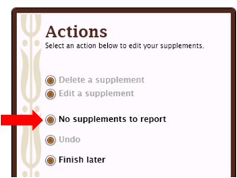
Back to top
What if I didn’t take any vitamins, minerals, or other supplements yesterday?
If you didn’t take any vitamins, minerals, or other supplements yesterday, select No Supplements to Report to move on.

Back to top
What should I do if I cannot complete ASA24 after starting it?
It’s best to report all your foods and drinks at one time, but if you can’t, press Finish later on the Actions panel on the left side of the screen.
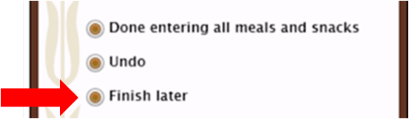
Your answers will be saved and you can come back later today to finish. If you had a problem like your browser or computer shutting down, try to log back in today – your answers are saved as you complete each step so you will be able to see where you left off and finish.
Back to top
I am stuck and can’t move on – what should I do?
Make sure that you have answered all of the questions on the screen. Most screens have a Next button that won’t be active until you answer everything.
If your internet browser or computer is not responding and you need to shut down, you can log back in the same day to finish – your answers are saved as you complete each step so you will be able to see where you left off or close to it.
Back to top
I can’t hear the penguin – what should I do?
If you can’t hear the penguin, check to make sure that your computer speakers are turned on and try adjusting the volume. Also, select Penguin Options in the top right corner of the screen to make sure that the penguin’s voice is turned on.
If you don’t have speakers or if your speakers aren’t working, you can read what the penguin says in the text bubbles.
Back to top
How do I turn the penguin off or back on again?
Select Penguin Options at the top right corner of the screen.
You can then turn off the penguin’s voice (you can still read what the penguin says in the text bubbles). You can also make the penguin disappear if you are comfortable with ASA24 and don’t need help. If you change your mind, press Penguin Options again to turn the penguin back on.
Back to top
How do I change the text size to be larger or smaller?
Select one of the three As (A A A) in the top right corner of the screen to change the font size to small, medium, or large.
Back to top
Where can I find help?
Help is available in three places:
- Review the questions and answers in this document.
- Make sure the penguin is turned on (see Penguin options in the top right corner of the screen) so that you can get instructions.
- Select the blue question marks () that appear on some screens for additional help.
If you require further assistance, please contact the person who asked you to complete ASA24.
Back to top

