Quick Start Guide for Participants
ASA24™ asks you about the foods, drinks, vitamins and supplements you had yesterday.
- We understand that what you eat from one day to the next can be quite different.
- Enter only the foods, drinks, and supplements you actually had yesterday, even if they do not reflect your usual diet.
A guide in the form of a Penguin offers instructions and guidance as you move through ASA24™.
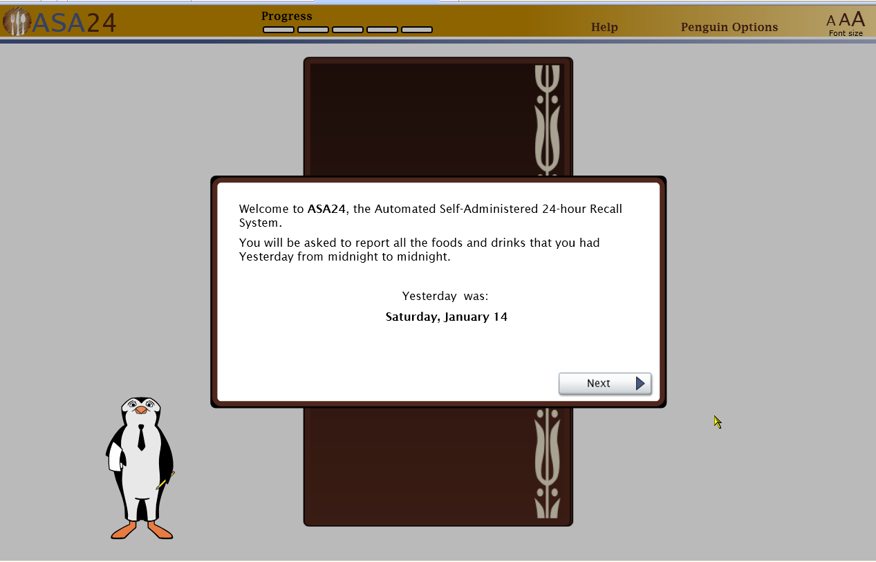
The general sequence of the questionnaire is:
- Report details for a meal or snack (e.g., what meal it was, such as breakfast; what time you had it)
- Report the foods and drinks you had at the meal or snack
- Repeat steps 1 and 2 as necessary
- Select Done entering all meals and snacks
- Answer detailed questions about the foods and drinks, including how they were prepared, the amount you ate or drank, and any foods added to the main food or drink (e.g., butter on potatoes, milk to cereal)
- Double check that frequently forgotten foods and drinks were reported
- Review the foods and drinks reported
- Report supplements, including vitamins and minerals
- Report the amount of supplements taken
An image of the main screen appears below. The Penguin will describe the different parts of the screen and how to use them to report what you ate and drank yesterday.
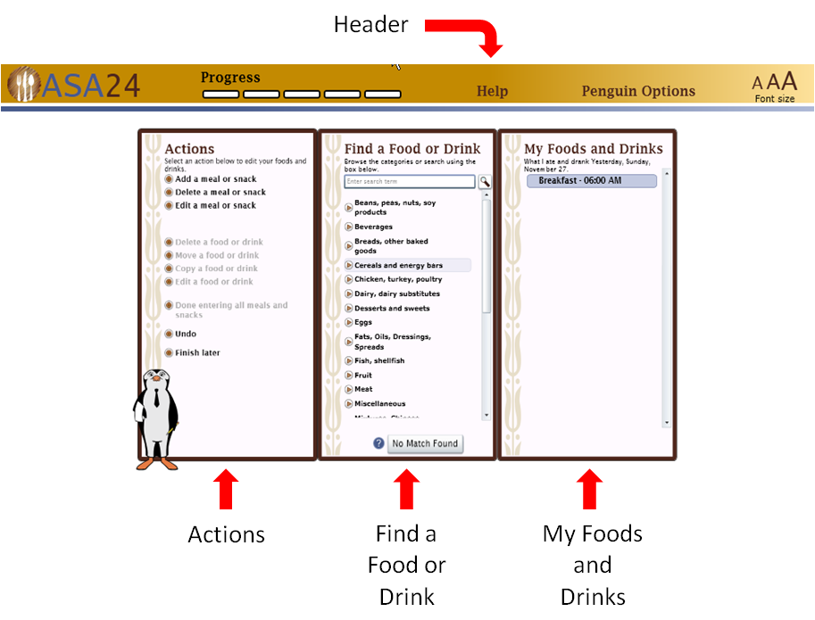
Use the middle panel to look for your foods and drinks within pre-defined food groups or by using the search box.
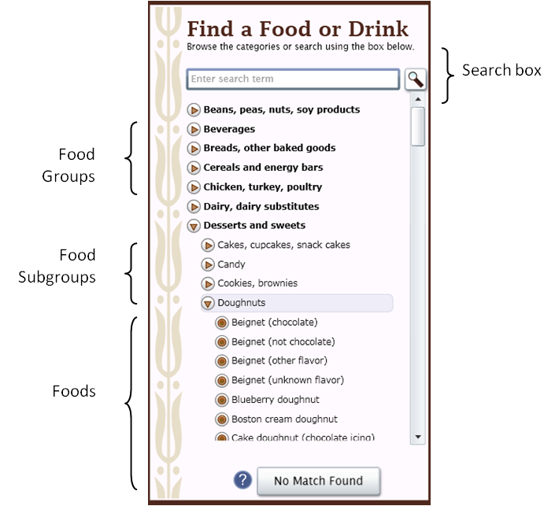
Select the option at the top to view frequently asked questions.
Select the button to see specific help.
Tips
- When reporting a food that contains multiple ingredients such as a sandwich, salad, or ice cream sundae, report the main food such as turkey sandwich or green salad. You will be prompted for items that made up the food. You do not need to report each ingredient separately.
- When you report a food or drink, you will be asked about items you may have added to the food or drink. For example, if you report crackers, you will be asked what you added to the cracker, like cheese. You do not need to report the cheese separately. If you added lemon to tea, report the tea and when you are asked if you added anything to the tea, you can report the lemon. You do not need to report the lemon separately.
- It may be hard to find exactly what you ate or drank because not all brand names are included in ASA24™. Please find the closest match.

