Preparing Your Computer for ASA24
Chrome
This document contains information about preparing your computer to complete ASA24™ on the web if you are using Chrome to browse the internet.

Microsoft® Silverlight™
Microsoft® Silverlight™ is a free program called a plug-in that allows you to experience a website’s full set of features such as animation.
You may already be familiar with a similar plug-in called Flash from Adobe. Flash has been around for much longer and most computers already have it installed. Silverlight is newer and growing in use but you may not have yet had a chance to install it on your computer.
Silverlight version 4.0 or higher is needed to complete ASA24™. If you do not already have it installed on your computer, you will need to install it before you will be able to log in to ASA24™. You will only need to install Silverlight once in the browser you will be using. But if you use a different browser (e.g., Internet Explorer, Firefox, or Safari) next time you use ASA24™ on your computer or use a different computer to complete ASA24™, you may have to install it again. It takes less than 1 minute to install Silverlight.
Note regarding Apple computers, iPhones, and iPads: Because Silverlight is relatively new, it will run on Intel-based Macintosh computers (also known as Macs) but not on older Mac PowerPCs. Intel-based Macs have been around for over five years so if you have a Mac, chances are it is an Intel-based Mac. ASA24™ cannot be completed on Apple’s iPhones or iPads because they do not support Silverlight.
Please note: ASA24™ displays a lot of information at once so it is best viewed on a monitor that supports a minimum resolution of 1024x768 or greater. While ASA24™ will proportionally scale to lower resolutions, you may find it difficult to use.
Known issues when using MacOS and Chrome to run Silverlight Applications like ASA24™

The Silverlight Plug-in, required to run ASA24™, is not supported by Chrome, version 12 and higher when Chrome is used on a Mac using OS 10.5.7 and higher. If you attempt to begin ASA24™ using Chrome 12+ on a Mac OS 10.5.7+, you will be alerted to try a different browser.

See http://www.microsoft.com/getsilverlight/Get-Started/Install/Default.aspx for compatible operating systems and browsers. The Silverlight Download Guides have been updated to reflect this issue.

How do I know if I have Silverlight installed?
There are a few ways you can check to find out if the plug-in is enabled in your browser. The easiest way is to let ASA24™ check for you.
When you are notified to complete ASA24™, log in to asa24.westat.com using the username and password assigned to you. Click Begin ASA24 (Figure 1).
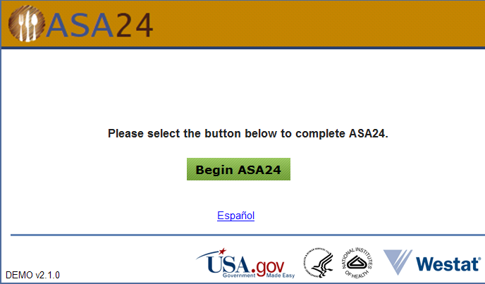
Figure 1
If you have the Silverlight plug-in installed, ASA24™ will launch.
If you do not have the Silverlight plug-in installed, you will see the message displayed below in Figure 2.
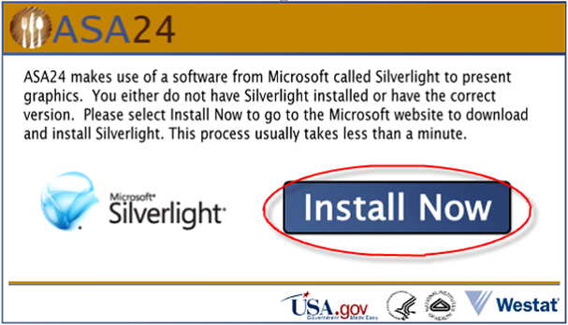
Figure 2
Step 1: To install Silverlight, click or select the button shown in Figure 2.
Step 2: Next you will be redirected to the official Microsoft Silverlight website (Figure 3).
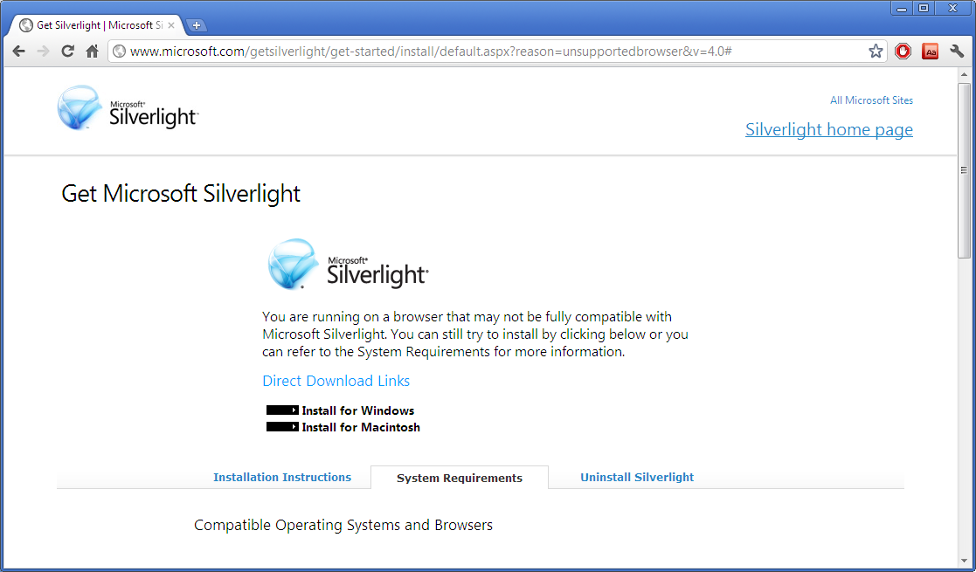
Figure 3
Depending on the operating system you are using, choose Install for Windows or Install for Macintosh.
You will see the selected download file at the bottom of the Chrome browser (Figure 4).
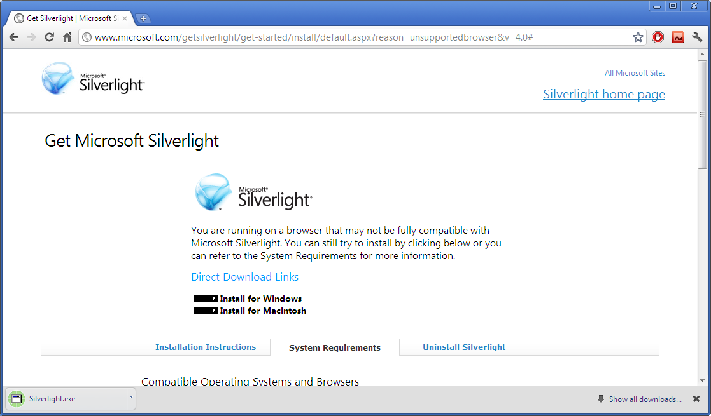
Figure 4
Step 4: Click on the Silverlight.exe to start the installation (Figure 4).
Step 5: Depending upon your PC’s security settings, you may be further prompted to verify the installation. You may see a warning similar to the one shown in Figure 5.
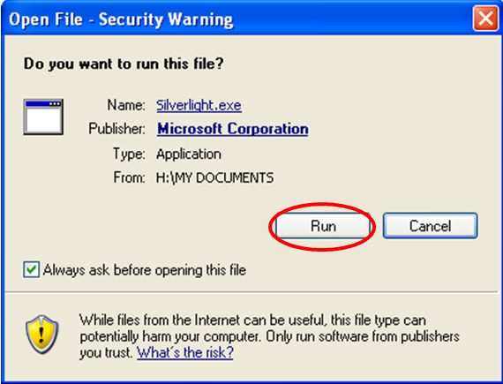
Figure 5
Select the button to confirm that you wish to install Silverlight (Figure 5).
Step 6: The below message will appear (Figure 6).
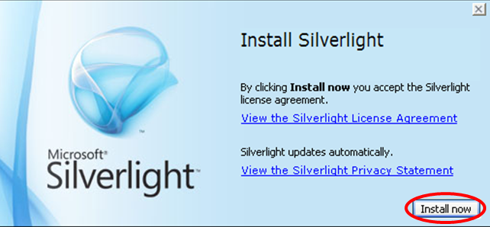
Figure 6
Select the button in Figure 6 to begin the installation.
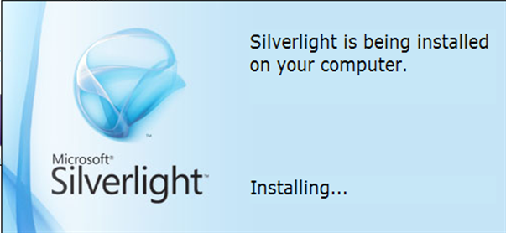
Figure 7
Step 7: Once installation has been completed, you will see a confirmation that the installation has been successful (Figure 8).
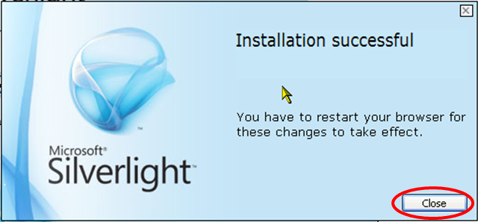
Figure 8
Select the button in Figure 8 to return to ASA24™.
Step 8: You can now return to your browser and select the Begin ASA24 button (Figure 1) to start completing ASA24™.

